Personalised Engagement Strategies for Sustainable Fundraising

MIS784 Marketing Analytics - Assignment 3 (Group)

Group Number: 60

**Student Name & ID:**

Ba Huy Hoang Le, 224309594

Jayseon Choi, 224262509

Simran Thakur, 224770284

**Table of Contents**

Table of Contents

Executive Summary 4

Understanding the Consumers 5

Methodology 6

Evaluating the Performance 7

1. Donor Behaviour Patterns 7

1.1 Monetary Patterns 7

1.2 RFM Segmentation 7

1.3 Payment Method Preferences and Performance 8

1.4 Engagement Metrics 8

2. Churn Risk & Retention 9

2.1 Campaign Response Rates 9

2.2 Click-Through & Engagement 10

2.3 Outlier Behaviour 10

2.4 RFM Drivers of Retention 11

2.5 Demographic Influences on Retention 11

Revenue Optimisation 12

3.1 Donations Seasonality 12

3.2 High-Value Contributor (Top 5% Across Both Domains) 13

3.3 Game Genre and Device Performance 13

3.4 Campaign Effectiveness by Type and Target Audience 14

3.5 Campaign Response by RFM Segment and Campaign Type 14

3.6 Campaign Cost per Engaged Person by Campaign Type 14

Strategic Recommendations 16

1. Personalising Outreach 16

Action 1: Reactivate one-time donors with campaign updates 16

Action 2: Retain high-value in-app donors with behaviour-based reminders 16

Action 3: Engage younger in-app donors through game-themed messages 16

2. Deploying RFM-Based Predictive Retention System for Traditional Donors 17

Action 1: Build a predictive RFM scoring model 18

Action 2: Demographic customisation 18

Action 3: Tiered Intervention 18

Action 4: AI-Enhanced Personalisation 18

3. Tiered Incentives and Early Activation Strategies 19

Complying Proposed Recommendations with Privacy Regulation 20

References 21

# 

# 

# 

# 

# 

# 

# Executive Summary

MobileImpact generates funding through two channels: traditional donations via memberships, top-ups, and gifts, and mobile in-app purchases. This report analyses donor behaviour, churn risk, and campaign performance to recommend strategies for stronger retention and more stable revenue.

Five datasets (traditional, in-app, campaigns, demographics) were cleaned, merged, and analysed. Donors were segmented into five RFM groups (Cannot Lose, Active Fans, Promising Newbies, At Risk, Other). The analysis compared monetary patterns, engagement, churn signals, and campaign efficiency.

**Key Findings**

* Traditional giving is steady (median $96) and broadly distributed, while in-app is small (median $12) but highly concentrated, with 10% of users contributing 85.6% of revenue.
* Cannot Lose donors, though small in number, deliver the highest per-person returns; Promising Newbies in the app also show strong early value.
* Half of traditional donors gave only once, especially under-30s, while whales dominate in-app revenue despite similar play activity to others.
* Campaign response differentiates loyalty in-app (91% vs 79%) but not in traditional giving, where RFM scores are better churn predictors.
* Email is most cost-efficient, Social Media best for re-engagement, and Direct Mail most effective for onboarding.

Revenue stability depends on protecting Cannot Lose donors, re-engaging At Risk supporters, and reducing reliance on whales by activating new and younger donors.

**Recommendations**

* Personalise outreach to one-time and younger donors, using campaign-linked updates and GenAI to scale message creation.
* Retain whales and dolphins with behaviour-based reminders highlighting impact and encouraging continued giving.
* Deploy predictive RFM scoring for traditional donors to flag churn risk and prioritise interventions.
* Introduce tiered incentives: exclusive bundles for whales, progression rewards for dolphins, and starter packs for minnows.
* Optimise channel mix: email for efficiency, social media for re-engagement, and direct mail for targeted renewals.

By combining RFM-based predictive analytics, personalised outreach, and tailored incentives, MobileImpact can reduce churn, strengthen donor loyalty, and stabilise revenue streams while ensuring compliance with data privacy regulations.

# Understanding the Consumers

MobileImpact’s supporters contribute through two main channels: traditional donations and mobile in-app purchases. Traditional donors give through Products such as Memberships, Membership TopUps, and General donations, with their Donation Amount and renewal status recorded over time. Their behaviour is closely linked to Donation Date, continuity of active memberships, and preferred Channel Pay. These donors form the foundation of long-term revenue, but risks arise when memberships lapse or donation frequency declines.

In contrast, mobile in-app contributors engage through gaming platforms. Their activity is tracked by Device, Game Genre, and Session Count, with In-App Purchase Amount attributed to Spending Segment categories such as minnows, dolphins, and whales. While most contribute small amounts, a small high-value group generates a disproportionate share of revenue. Early behaviours, such as First Purchase Days After Install and use of app-linked Pay Methods, are strong indicators of engagement and retention.

Both groups also interact with MobileImpact’s Marketing Campaigns, where the performance is measured by Response, Click Through Rate, and Engagement Frequency which shows how different segments react to campaign types such as email, social media, or direct mail. Understanding these interactions helps identify which supporters respond best to which channels, and how budget allocation can maximise reach and efficiency.

# 

# Methodology

To evaluate donor behaviour, churn risk, and revenue opportunities, several analytical steps were taken:

**Data Preparation**

All five datasets provided by MobileImpact were combined and cleaned to ensure reliable analysis. Missing values, duplicates and extreme outliers were addressed. Active memberships were flagged for clear identification, and campaign responses were deduplicated at the customer-campaign level to ensure each supporter was counted only once.

**Donor Segmentation and Profiling**

To understand different donor behaviours, Recency, Frequency, and Monetary (RFM) scores were calculated for both traditional and in-app contributions. These measures identified how recently a donor gave, how often they gave, and how much they contributed. Supporters were subsequently grouped into five meaningful categories: Cannot Lose, Active Fans, Promising Newbies, At Risk and Other. This segmentation was applied consistently across analyses to compare engagement, campaign performance and retention.

**Churn and Retention Modelling**

The RFM framework was extended to explore drivers of donor retention and attrition. Key patterns such as giving frequency, recent activity and contribution size were compared across segments to identify which donors were most at risk of leaving. Demographic details (age, income level, family size, gender) were also incorporated to determine which groups were most likely to remain engaged or lapse.

**Revenue and Contribution Analysis**

Donation trends were examined over time to capture seasonal and monthly effects. High-value contributors (top 5% of all transactions) were isolated to assess their behaviors, and in-app donors were profiled further by game genre and device type to understand what drives higher engagement. This approach helped distinguish between broad donor bases and smaller groups of high-yield contributors.

**Campaign Effectiveness Evaluation**

Finally, campaign responses were evaluated across multiple communication channels (email, SMS, social media, and direct mail). Performance was measured in terms of response rates, click-through rates, engagement levels, and budget efficiency. Results were also disaggregated by RFM group to show which segments respond best to which channels.

# Evaluating the Performance

## Donor Behaviour Patterns

### 1.1 Monetary Patterns

Traditional donors provide steady mid-sized contributions. The typical donation is $96, with half falling between $30 and $336. Memberships anchor this channel (median $144), while general donations are smaller (median $60) but can reach $5,000. Membership top-ups are modest (median $20) and play a supporting role. Overall, traditional giving is built on reliable membership revenue, with occasional large one-off gifts adding scale.

In-app contributions follow a different pattern. The typical gift is just $12, with most between $6 and $18. Minnows give around $10, dolphins $246 (similar to memberships), and whales $2,600, with many above $4,000. Most users give very little, while a small minority give at very high levels. This creates a sharp divide: the top 10% of in-app donors account for 85.6% of all revenue, compared to 31.9% in the traditional channel. Traditional giving is broader and more balanced, while in-app depends heavily on whales.

### 1.2 RFM Segmentation

Customers were segmented into five groups by recency, frequency, and monetary value. Total contributions reached $1.34m, mostly from the large “Other” group ($896,073 from 3,999 people, $231 each). The highest-value segment was “Cannot Lose,” generating $169,726 from 200 people, averaging $665 with nearly three donations each. “At Risk” gave $164,042 (1,108 people, $141 each), “Active Fans” $72,527 (258 people, $272 each), and “Promising Newbies” $33,226 (101 people, $425 each). This shows the base group drives volume, while smaller segments deliver higher per-person returns.

Traditional donors give more per person: “Cannot Lose” averaged nearly $1,000 with 4.4 donations, while “At Risk” averaged $271 with 1.6. The “Other” group remained the largest, contributing $664,033 from 1,889 donors. In contrast, in-app giving relies on scale, with “Other” contributing $232,040 from 2,110 customers at just $110 each. “Promising Newbies” stood out here with $26,035 from 88 people ($296 each), while “Active Fans” added $17,196 from 120.

The priority is to protect “Cannot Lose” donors, given their outsized value, through recognition, early renewal prompts, and quick service recovery. “At Risk” traditional donors also matter, as small reactivation gains could lift significant revenue. The “Other” group sustains volume but should be managed through low-cost, automated outreach. In the in-app domain, “Promising Newbies” warrant early engagement to encourage repeat purchases and build them into more loyal contributors.

### 1.3 Payment Method Preferences and Performance

In-app contributors favour digital-first payments, with debit cards (15.1%) and Google Pay (14.9%) slightly ahead, followed closely by carrier billing, gift cards, credit cards, PayPal, and Apple Pay (12.8–14.5%). No single option dominates, but the concentration around mobile wallets and debit reflects the mobile-first context where quick, app-linked methods are standard.

Traditional donors exhibit a more even distribution. Online banking (13.4%), mobile payments (12.6%), cash (12.5%), PayPal (12.5%), debit (12.4%), cryptocurrency (12.4%), bank transfers (12.2%), and credit cards (12.0%) all receive nearly equal usage. This balance suggests a need for broad coverage, capturing both older donors who prefer cash and younger donors experimenting with crypto.

### 1.4 Engagement Metrics

Among traditional donors, donation is evenly split between one-time and repeat contributors. Just under half (49.6%) donated once, while 50.4% gave more than once, averaging 1.8 donations each. From Figure 1, Younger donors (< 30) are the least likely to return: 54.7% donated only once, and just 2% donated five or more times. By contrast, donors aged 45–59 were more committed, with 7.4% donating five or more times. Older groups overall are more likely to remain engaged.

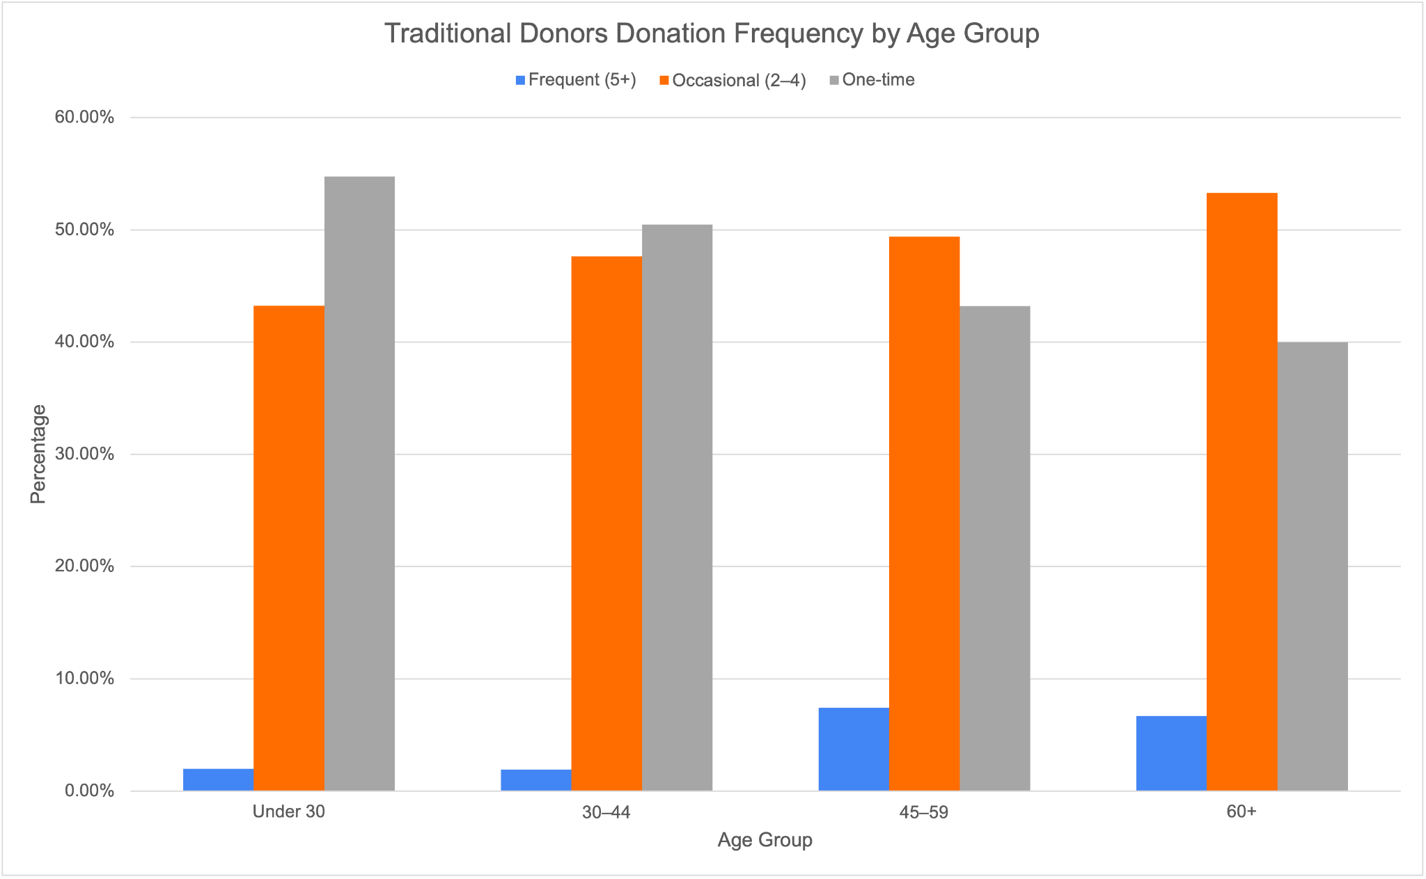

***Figure 1:*** *Traditional Donors Donation Frequency By Age Group*

Recency patterns highlight donor attrition across all ages. The average gap since last donation is 269 days, with two-thirds of donors across all age groups inactive for more than 180 days, as shown in Figure 2. Figure 2 also shows that only 16% occurred within the last 90 days, and this proportion is consistent across age groups. Younger donors therefore lapse sooner and donate less often, while older donors, though also at risk of lapsing, show higher repeat giving.

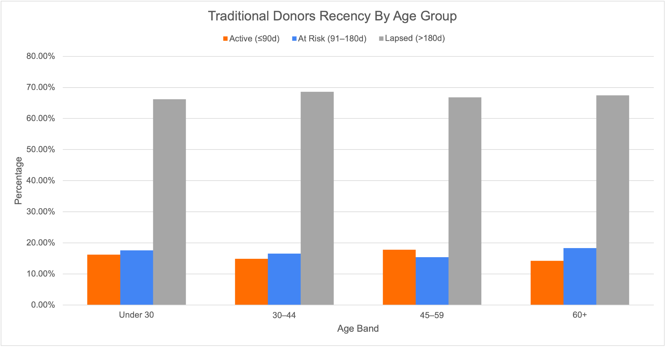

***Figure 2:*** *Traditional Donors Recency By Age Group*

In-app contributors behave differently. They convert quickly, with first purchases made after about 15 days, and average 10 sessions of 20 minutes each. Spending is highly concentrated: whales spend $2,850 on average compared to $246 for dolphins and $10 for minnows, despite similar play activity. Genre preferences vary, with dolphins favouring adventure, fighting, and MMORPG, while whales and minnows are more evenly spread.

## Churn Risk & Retention

### 2.1 Campaign Response Rates

Campaign engagement predicts churn in the app, but not for traditional donors. App users in our strongest loyalty tier (Cannot Lose) respond to 91% of campaigns, dropping to 83% for Active Fans and 79% for At Risk supporters. This declining response pattern indicates an early churn signal. Traditional donors behave rather differently, where all segments respond at roughly 80-83%, with no meaningful differences in click-through or interaction rates. Hence, recency, frequency and monetary value provide superior churn prediction for traditional donors.

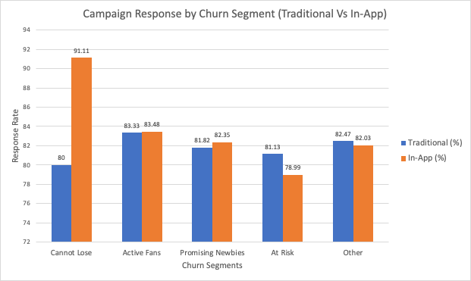

***Figure 3:*** *Campaign Response by Churn Segment(Traditional vs In-App)*

The graph highlights that in the In-App channel, campaign response rates differentiate loyalty. Cannot Lose lead with a 91% response rate, while At Risk donors lag at 79%, indicating early warning signals of disengagement. By contrast, Traditional donors show consistent response rates tightly clustered between 80-83%, with Cannot Lose donors actually the lowest at 80%, suggesting that campaign response alone does not effectively distinguish churn risk in this group.

### 2.2 Click-Through & Engagement

Click-Through Rates(CTR) remain stable across segments, with donors clicking through about half the time and interacting 5 times per campaign. Even At-Risk donors interact similarly to Cannot Lose supporters, with only Promising Newbies showing weaker engagement. This stability reveals that campaign engagement alone cannot predict churn. Prediction must instead rely on response rates (in-app) and RFM transaction patterns (traditional), where clear differentiation exists between loyal and at-risk supporters.

### 2.3 Outlier Behaviour

Donations exhibit two extremes: many small donations under $10 and a very few large contributions. Revenue concentration analysis confirms this imbalance. In-app, the top 10% of customers generate 86.5% of revenue (92.8% from 20%), compared with 31.9% (51.4%) in traditional. This indicates heavy reliance on “whales” in the app channel, while traditional giving is more evenly spread. Sustaining stability requires protecting high-value donors while maintaining broad participation from smaller givers.

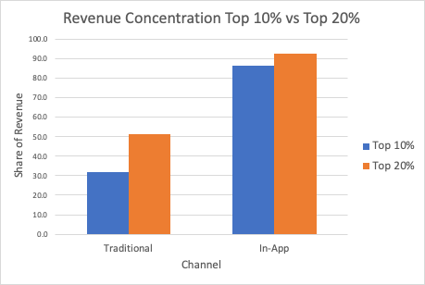

***Figure 4:*** *Revenue Concentration (Top-10% vs Top-20%)*

The graph shows in-app revenue is dominated by a small elite of donors, whereas traditional revenue is spread more evenly, underlying the importance of churn prevention among loyal, higher-value segments to protect funding for SDG-aligned programs.

### 2.4 RFM Drivers of Retention

The RFM analysis (which evaluates how Recently donors gave, how Frequently they gave, and how much Money they contributed) cleanly separates loyalty for traditional donors. Cannot Lose gives more frequency (4.4 times) and contributes higher totals ($1000), with shorter recency (more recent giving). At risk donors show older recency, lower frequency, and smaller totals ($271).

In the app channel, frequency is uniformly low (often one purchase), so monetary value is the key separator. Loyal supporters stand out by larger single-purchase totals, not by frequency.

### 2.5 Demographic Influences on Retention

Demographics help in getting a clearer picture of who stays engaged and who does not.

Age shows that Cannot Lose and Active Fans in our traditional channel tend to be older (40+ years), while app contributors are generally younger (mid-30s). Gender data is harder to interpret as many records show “Unknown”, but within available data, male and female participation looks fairly balanced.

Family Size also matters. Households with more members (averaging 3.5-3.8 people) tend to be more engaged in both channels, possibly reflecting a stronger sense of community and shared responsibility driving their giving decisions.

Income Level provides insights into donor loyalty. Cannot Lose donors are mostly medium-income households, while high-income donors are more evenly spread across segments. Importantly, At Risk donors also include many medium-high earners, indicating that retention challenges stem from engagement issues rather than financial constraints alone. Medium-income donors form the backbone of predictable funding across all segments. This highlights the need to focus on sustaining medium-income loyalty, while specialised appeals could be designed to capture and grow the contribution of high-income donors across multiple segments.

## Revenue Optimisation

### 3.1 Donations Seasonality

Donation activity showed clear seasonal shifts across Jan 2024-Aug 2025 (Figure 5). March 2024 was the strongest month, generating $102,098, largely driven by Memberships ($95,584, ave. donation $411). General donations peaked in June 2024 at $16,450, supporting mid-year appeals, while July 2024 produced the highest average donation at $287 despite fewer transactions. December 2024 recorded the largest transaction count (436) but at a lower average donation of $169, highlighting its role as a broad participation period. From January 2025, donations declined steadily, with the average donation falling from $199 in January to just $29 by August 2025. This trend underscores the importance of early-year renewals and mid-year premium appeals, while year-end and 2025 activity reflect volume-driven but lower-value participation.

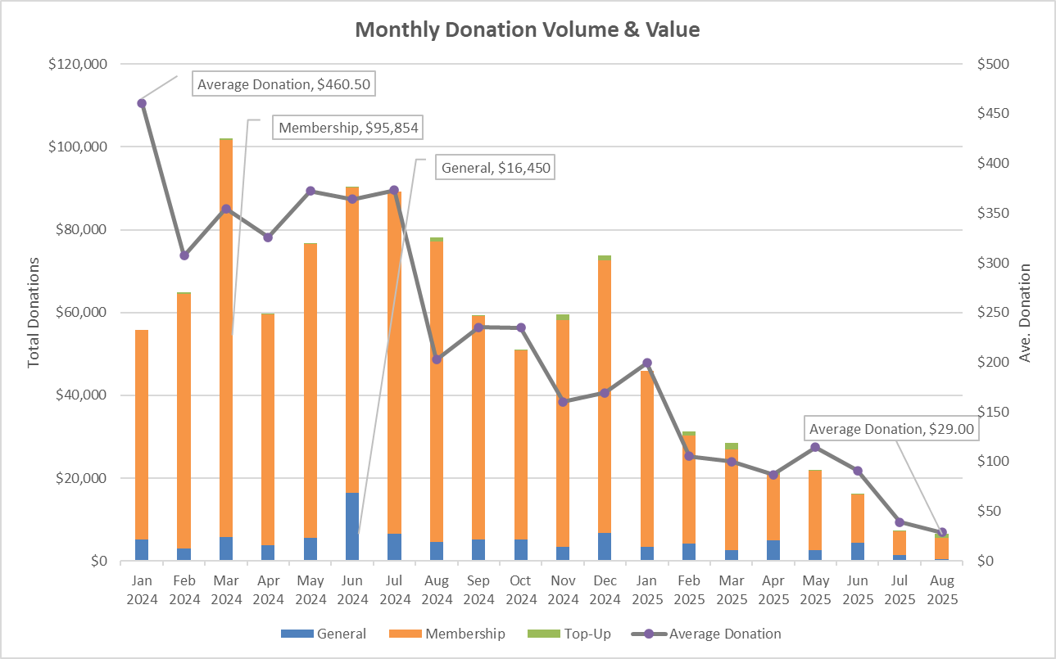

***Figure 5.*** *Monthly donation volume and value (Jan 2024-Aug 2025), showing March 2024 as the revenue peak ($102,098), December 2024 as the highest participation month (436 donations, avg $169), and a steady decline to August 2025 (avg $29).*

### 3.2 High-Value Contributor (Top 5% Across Both Domains)

The top 5% of donors contributed $233,179 through donations (average $882) and $211,703 through in-app purchases (average $1,460). Donations reflect repeated high-value giving, while in-app spending comes from fewer but larger transactions. Retaining these supporters calls for a unified high-value program with timely recognition, priority service, and tailored follow-ups. For in-app donors, exclusive bundles or loyalty rewards after major contributions should be a standard offering.

### 3.3 Game Genre and Device Performance

Revenue is concentrated in a few genre-device pairs: iOS Battle Royale ($17,388), Android Strategy ($16,808), iOS Racing ($15,635), Android MOBA ($15,590), and Android Fighting ($15,139). These combinations consistently generate over $15,000 with session lengths of 18-21 minutes. Deeper engagement is seen in Android Battle Royale (22 minutes) and iOS MMORPG (21.6 minutes), suggesting these genres are suited for time-gated bundles, streak rewards, and progression offers. Addressing gaps in missing device data could also uncover additional high-engagement groups.

### 3.4 Campaign Effectiveness by Type and Target Audience

Response rates across channels cluster around 0.50. Social Media achieved the highest response (0.503) and strong engagement (5.02), while SMS performed similarly but at a higher cost. Email was slightly lower (0.487) but remains the most cost-efficient. Audience analysis also shows New Donors respond best to SMS and Direct Mail, Returning Donors to Social Media, and High-Value Donors equally to Email and Social Media. This supports a rather layered approach: Email for scale, Social Media for interactive re-engagement, and Direct Mail for new donor conversion.

### 3.5 Campaign Response by RFM Segment and Campaign Type

As shown in Figure 6, Active Fans respond strongest to Email with a 0.59 rate, 0.53 CTR, and ave. engagement of 4.86, while SMS also performs well with the highest engagement (5.17). At Risk donors show the highest performance through Social Media (0.51 response, 0.50 CTR, 4.99 engagement). Cannot Lose and Other donors achieve their best outcomes through Direct Mail (0.49-0.50 response, engagement above 4.6) slightly ahead of Email. Promising Newbies are the outlier, recording a perfect 1.00 response to Direct Mail but with weaker CTR (0.34) and engagement (3.00), while Email returns only a 0.25 response. These results suggest Email should remain the default channel for scale, Social Media is most effective for re-engaging At Risk supporters, and Direct Mail is best used selectively for renewals, onboarding, or relationship management, especially for Promising Newbies where its high initial lift can be followed by lower-cost Email to sustain momentum.

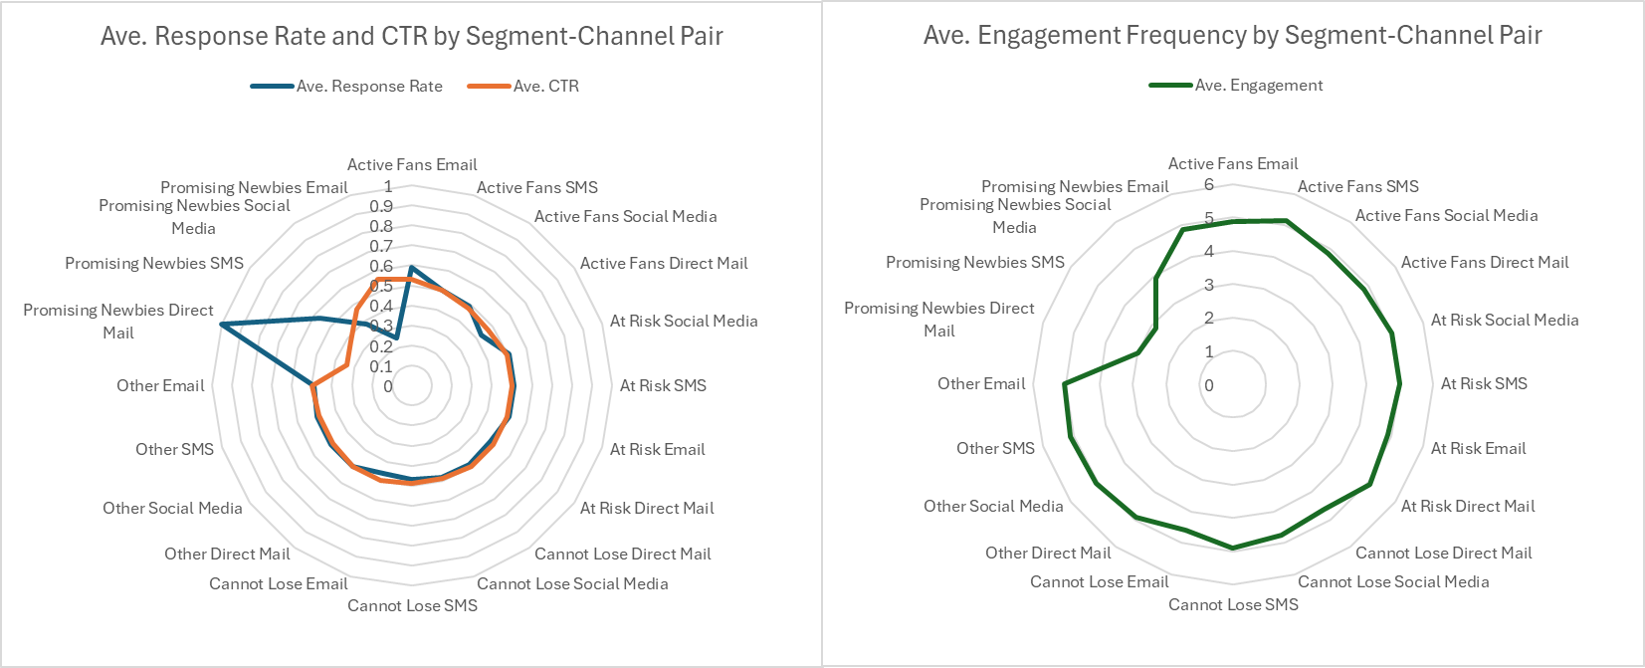

***Figure 6.*** *Campaign performance across RFM segments and channels, showing response rate and CTR (left) and average engagement frequency (right).*

### 3.6 Campaign Cost per Engaged Person by Campaign Type

Channel efficiency analysis confirms Email as the most cost-effective at $1,279 per unique engaged person and $1,151 per engagement from a $1.05 budget, reaching 817 people across 908 engagements. Social Media follows at $1,340 per unique and $1,096 per engagement, delivering the widest reach with 1,317 people and 1,610 engagements on a $1.77m budget. Direct Mail is slightly higher at $1,396 per unique and $1,205 per engagement, engaging 972 people across 1,126 interactions on $1.36m. SMS is the least efficient, at $1,491 per unique and $1,234 per engagement, reaching 1,371 people across 1,656 engagements from a $2.04m budget. Thus, these results support a tiered channel plan: Email as the default for broad coverage and efficiency, Social Media when higher engagement justifies added spend, Direct Mail for targeted relationship management or new donor conversion, and SMS for urgent, time-sensitive campaigns where immediacy outweighs cost.

## 

# Strategic Recommendations

## Personalising Outreach

Personalising outreach involves tailoring messages to donor behaviour, contribution value, and engagement context. Based on the analysis, three targeted actions are recommended.

### Action 1: Reactivate one-time donors with campaign updates

Almost half of traditional donors (49.6%) gave only once, and this rises to 54.7% among those under 30. Younger donors are also less likely to give again, with only 2% contributing five or more times. To re-engage these segments, MobileImpact can send personalized messages that reference the specific cause each donor previously supported. For example, a donor who gave to a health campaign could receive an update showing real outcomes from that initiative, followed by an invitation to continue their support. A templated prompting system using a pre-trained GenAI model can automate the generation of these short messages by combining structured campaign data with age-based tone adjustments and preferred formats such as SMS or Instagram (Ruiz-Pozo et al., 2024). This approach removes the need for training a custom model, while enabling rapid and cost-effective message production across campaigns.

### Action 2: Retain high-value in-app donors with behaviour-based reminders

The top 10% of in-app donors contribute 85.6% of total revenue, yet their playtime is similar to that of lower-tier donors. This suggests that financial commitment is not linked to time spent in the app. These donors, categorised as whales and dolphins, can be retained through well-timed reminders when their activity or spending slows. Personalised messages can highlight the real-world impact of their past contributions and encourage continued giving (Mallikarjuna & Chittemsetty, 2024). A GenAI content generator built on MobileImpact’s donation archive and campaign impact summaries can produce message variants by donor tier, theme, and urgency level. The system selects appropriate tone and message framing (e.g. “You helped deliver 50 school kits” vs “Your support can double access today”) based on recent activity patterns and value group.

### Action 3: Engage younger in-app donors through game-themed messages

Many in-app donors, especially dolphins, are drawn to genres such as adventure, fighting, and MMORPG. Younger donors, however, tend to contribute small amounts and rarely return. MobileImpact can develop game-style donation prompts tailored to each genre. For example, a message styled as a quest completion could encourage support for an education campaign aligned with SDG 4. A custom-built GenAI prompt engine can generate message text and visual elements using in-game vocabulary and design logic (Rozo-Torres & Sarmiento, 2024). For instance, in adventure games, the prompt mirrors a level-up mechanic; in MMORPGs, it frames donation as a co-op achievement. This approach allows thematic alignment without interrupting the player experience.

**Key Performance Indicator**

|  |  |
| --- | --- |
| Action | Target |
| 1 | * Increase repeat donation rate among one-time donors from 50.4% to 55–58% * Achieve 20–25% CTR for under-30s, 15–20% for others * Generate 100% of re-engagement messages via GenAI with a 50% reduction in manual copywriting time |
| 2 | * Retain ≥70% of whales and dolphins over 60 days * Maintain whale spend at ≥$2,600; increase dolphin avg. to $270 * Test 3+ GenAI variants per tier, identify 1 with ≥10% uplift |
| 3 | * Double second donation rate among under-30s (e.g. 8% → 16%) * Achieve ≥20% CTR for genre-personalised messages * Lift campaign engagement by ≥15% vs non-personalised prompts |

***Table 1****. KPIs Target for MobileImpact to Personalise Outreach*

## Deploying RFM-Based Predictive Retention System for Traditional Donors

MobileImpact’s traditional channel generates $890,000 annually from 2778 donors, but faces serious retention challenges: 67.2% are inactive beyond 180 days and 49.6% are one-time donors. Unlike in-app contributors, traditional donors maintain steady campaign engagement (80-83% response, 45-50% CTR) regardless of loyalty status. This surface-level engagement obscures the reality that donors continue opening emails while their actual donating behavior deteriorates. They remain interested but become inactive contributors.

Traditional channel’s balanced revenue distribution (top 10% generate 31.9% versus in-app’s 86.5%) still concentrates risk at the segment level 458 Cannot Lose and Active Fans donors provide $242,253 (18% of total revenue). Even modest losses would compromise MobileImpact’s capacity to maintain long-term SDG program commitments in education, health and poverty alleviation.

**The Solution: Predictive Analytics Using RFM-Patterns**

RFM analysis, tracking recency, frequency and monetary value, provides reliable churn prediction when behavioral metrics fail (Fader & Hardie, 2010). MobileImpact’s data shows Cannot Lose donors give 4.4 times annually averaging $1,000 with recent activity, while At Risk donors lapse 269 days with only $271-contribution. Acting early, before 60-90 days of defection, costs 40-60% less than recovery and boosts retention up by 95% (Kumar & Reinartz, 2018). However, donors may still appear engaged even as mission connection erodes, requiring transaction-level monitoring (Akhgari & Bruning, 2024).

**Implementation: Four-Strategic Actions**

### Action 1: Build a predictive RFM scoring model

Deploy machine learning models, such as logistic regression or gradient boosting, trained on 24 months of donor transaction data. These models generate 0-100 score weighted across recency (40%), frequency trends (35%), and monetary patterns (25%). Donors are reclassified weekly into Cannot Lose (80-100), Active Fans (60-79), Yellow Alert (40-59) and Red Alert (20-39). Prior research confirms that advanced predictive methods like support vector machines and neural networks are effective in CRM churn prediction. (Farquad, Ravi, & Raju, 2014; Iranmanesh et al., 2019). Furthermore, recent research demonstrates that machine learning based customer retention models improve user experience through personalized service delivery (Ibitoye, Kolade, & Onifade, 2025).

### Action 2: Demographic customisation

Tailor interventions by donor profile: medium-income donors receive recognition and community belonging, high-income donors access exclusive briefings and influence opportunities, and family-oriented households engage through child-focused -impact stories and multi-generational framing.

### Action 3: Tiered Intervention

Yellow Alert (40-59 score): Deploy automated recognition including impact certificates, virtual town hall invitations, and flexible payment options.

Red Alert (20-39 score): Activate personal outreach through direct calls with empathetic messaging and customized support offering paused or reduced commitments.

### Action 4: AI-Enhanced Personalisation

Implement generative AI content engine producing tailored communications at scale, customized by RFM segment, demographics, giving history and SDG preferences. Privacy compliance requires consent management, pseudonymized scoring storage, and GDPR-aligned data processing agreements ensuring ethical deployment.

**Key Performance Indicators**

* Reduce Cannot Lose donor churn by 10%
* Reduce Active Fans transitioning to At Risk by 8%
* Recover 10% of lapsed donor base annually
* Safeguard $23,000+ in Year 1revenue, scaling to $30,000 annual protection by Year 3

This model secures more predictable funding, allowing MobileImpact to sustain long-term SDG commitments. By shifting from reactive rescue efforts to proactive engagement, it preserves donor lifetime value, strengthens trust, and reduces reliance on volatile app-based revenue.

## Tiered Incentives and Early Activation Strategies

Analysis shows that whales (top 10% of users) generate 85.6% of in-app revenue, while minnows dominate by volume but contribute little. A tiered incentive strategy is then recommended, where:

* Whales should be retained with exclusive bundles, loyalty rewards, and personalised recognition within days of high-value purchases, as disengagement poses significant revenue risk (Paschmann et al., 2024).
* Dolphins, who spend an average $246 and favour Adventure, Fighting, and MMORPG titles, should receive progression bundles in long-session genres, where evidence shows progression rewards sustain deeper engagement (Paschmann et al., 2024).
* Minnows, while low-value, form the largest group of users. They should be engaged early with low-cost starter packs or micro-bonuses, consistent with strategies for Promising Newbies who require early activation to build loyalty (Barari, 2024).

Most first purchases occur within two weeks of installation, making early activation essential. Incentives such as first-purchase bonuses and short streak rewards triggered by First Purchase Days After Install and Session Count are supported by research on temporal discounting, which finds immediate rewards more effective than delayed ones (Garaialde, Cox, & Cowan, 2021).

Genres with longer play sessions, such as Battle Royale (22 mins.) and Racing (18-21 mins.), should be targeted with depth-based offers including time-gated bundles, loyalty streaks, and badges, all of which may reinforce achievement and encourage repeat play (Barari, 2024).

Finally, At Risk donors respond at lower rates (79%) than Cannot Lose contributors (91%). Re-engagement should focus on renewal bonuses or comeback offers delivered through social retargeting, as social campaigns perform best for this segment.

## Complying Proposed Recommendations with Privacy Regulation

To implement these AI-powered strategies responsibly, MobileImpact must ensure compliance with evolving data privacy regulations such as the GDPR. While personalisation and predictive modelling are central to outreach, retention, and incentive systems, donor data must be protected from exposure or misuse. Techniques like federated learning allow campaign response models and GenAI content generators to be trained using localised behavioural data such as donation history or in-app activity without transferring sensitive donor records to central servers (Li et al., 2025). Differential privacy can then be applied to summary statistics such as RFM scores or segment response rates by adding calibrated noise, ensuring that individuals cannot be re-identified even in highly targeted campaigns (Alzoubi and Mishra, 2025). This approach enables MobileImpact to personalise content, activate timely interventions, and tailor engagement to donor preferences while maintaining legal compliance and donor trust.

# References

Akhgari, M., & Bruning, E. R. (2024). How Attitudes Translate to Loyalty: An Integrative Model in Service Relationship Marketing. *Journal of Relationship Marketing, Oct-Dec2024*, p356-391.

Alzoubi, Y. I., & Mishra, A. (2025). Differential privacy and artificial intelligence: Potentials, challenges, and future avenues. *EURASIP Journal on Information Security, 2025,* 18.<https://doi.org/10.1186/s13635-025-00203-9>.

Barari, M. (2024). How and when does gamification level up mobile app effectiveness? Meta-analytics review. *Marketing Intelligence & Planning, 42*(6), 1093–1114.<https://doi.org/10.1108/MIP-10-2023-0569>.

CRM Magazine. (2013, August 1). First-ever predictive apps for salesforce and the service cloud. pp. Vol. 17, Issue 8, p16, 1 p.

Fader, P. S., & Hardie, B. G. (2010). Customer-Base Valuation in a Contractual Setting: The Perils of Ignoring Heterogeneity. *Marketing Science,2010*, 29(1), 85-93.

Farquad, M., Ravi, V., & Raju, S. B. (2014). Churn prediction using comprehensible support vector machine: An analytical CRM application. *Applied Soft Computing Journal,June 2014*, 31-40.

Garaialde, D., Cox, A. L., & Cowan, B. R. (2021). Designing gamified rewards to encourage repeated app selection: Effect of reward placement. *International Journal of Human-Computer Studies, 153,* 102661.<https://doi.org/10.1016/j.ijhcs.2021.102661>.

Ibitoye, A. O., Kolade, O., & Onifade, O. F. (2025). Customer retention model using machine learning for improved user-centric quality of experience through personalised quality of service. *Journal of Business Analytics,Aug2025*, p1-19. 19p. 10.

Iranmanesh, S., Hamid, M., Bastan, M., Hamed Shakouri, G., & Nasiri, M. (2019). Customer churn prediction using artificial neural network: An analytical CRM application. *Proceedings of the International Conference on Industrial Engineering and Operations Management, 2019*.

Kumar, V., & Reinartz, W. (2018). *Customer relationship management: Concept, strategy and tools.* Springer.

Li, X., Lin, Y., & Zhang, Y. (2025). *A privacy-preserving framework for advertising personalization incorporating federated learning and differential privacy*. arXiv.<https://arxiv.org/abs/2507.12098>.

Mallikarjuna, B., & Chittemsetty, P. (2024). Generative Artificial Intelligence: Fundamentals and Evolution. In D. Singh (Ed.), Generative AI: Current Trends and Applications (pp. 3–17). Springer. <https://link.springer.com/chapter/10.1007/978-981-97-8460-8_1>

Paschmann, J. W., Bruno, H. A., van Heerde, H. J., Völckner, F., & Klein, K. (2024). Driving Mobile App User Engagement Through Gamification. *Journal of Marketing Research*, *62*(2), 249-273.<https://doi.org/10.1177/00222437241275927>.

Rozo-Torres, A., & Sarmiento , W. J. (2024). Prompt Engineering, An Alternative for Video Game Development? Human-Computer Interaction, 1877, 242–256. <https://link.springer.com/chapter/10.1007/978-3-031-57982-0_19>

Ruíz-Pozo, I., Morales-García, J., Aguirre-Mejía, C. X., & Serrano, A. (2024). Using Generative Artificial Intelligence to Improve User Engagement in Content Marketing.<https://doi.org/10.2139/ssrn.4982145>